FD10N - FD10N - Customer Account Balance Display

Functionality
Every time you post a document, the system automatically updates a customer account and the relevant GL account (reconciliation account) balance.
This document covers Customer Account Balance Analysis. The account balance displays:
- The opening balance (the balance carried forward from the previous year)
- The total of all transactions for each posting period, broken down into debit and credit postings (transaction figures)

Scenario
You want to check and print a customer account balance.

Requirements
Defined Customer Master and posted customer documents.

Menu Path | Accounting → Financial Accounting → Accounts Receivable → Account → FD10N - Display balances
Transaction Code | FD10N
1. Double click on FD10N - Display balances.

Customer Balance Display

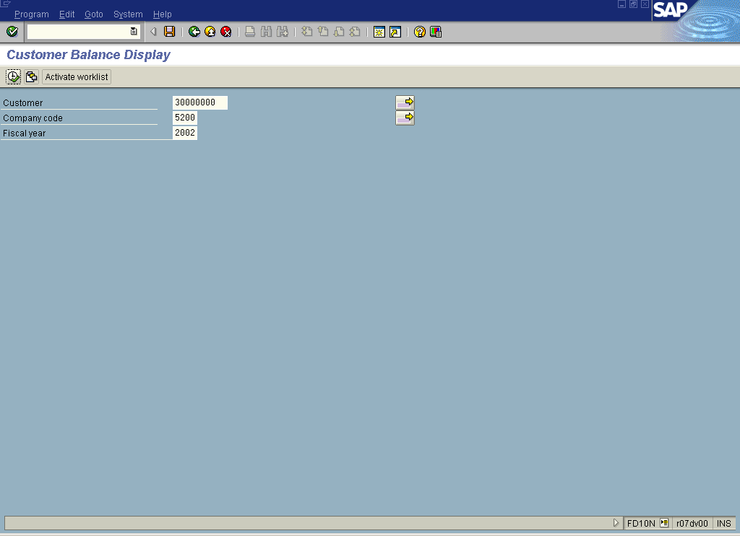

2. Update the following fields:

Field Name | Field Description | Values
Customer | Code identifying a customer account | Example: 30000000
Company code | Code identifying a separate legal entity for which a separate set of accounts is maintained for external reporting purposes | Example: 5200
Fiscal year | Fiscal Year number | Example: 2002

3. Click Enter Button to confirm your entries.

4. Click Execute button to display the account balance:

Customer Balance Display

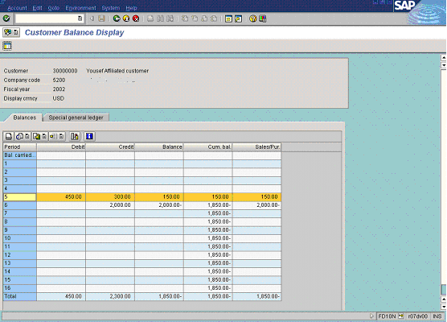

5. You can display the line items or even particular document directly from this report. For instance, to display all the documents for May, 2002 (balance $150,-) mark this row on the repot screen (it will be highlighted in yellow) and double click on the line item or click Call up line item report Button . You can see now all the documents posted in May:

Customer Line Item Display

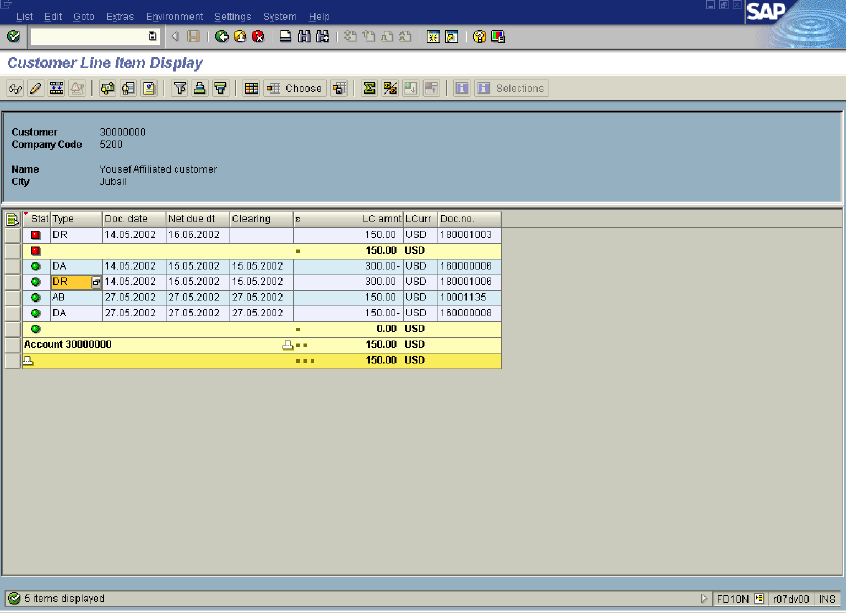

6. If you want to see the details of one of the documents, double-click on the line that contains the required document, e.g. 180001006. The system will display the details of this line item:

Display Document: Line Item 001

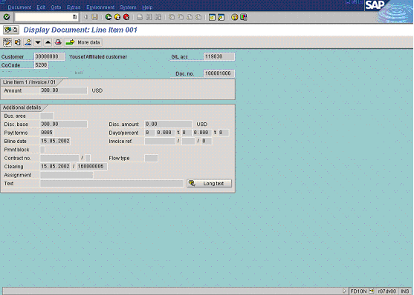

7. If you need, you can change some of the fields. Click Display -> Change Button . The fields that can be changed are highlighted in red. For instance you can change the description of the field “Assignment”:
Change Document: Line Item 001

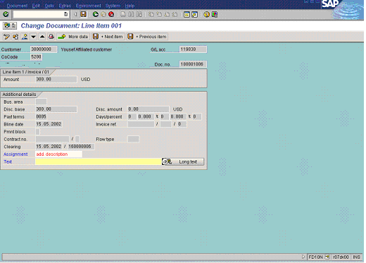

8. Update the following fields:

Field Name | Field Description | Values
Assignment | Line item description | Example: add. description

9. Click Save Button to update the document.

10. The message bar displays “Changes have been saved”

